**Assignment 2 (Insertion in an Array**)

**i) In the beginning:**

**Code:**

#include <iostream>

using namespace std;

int main()

{

int arr[100] = {0};

cout<<"Enter the first five elements : ";

for(int i = 0; i < 5; i++){

cin>>arr[i];

}

int element;

cout<<"Enter the element to be added : ";

cin>>element;

for(int i = 4; i >= 0; i--){

arr[i+1] = arr[i];

}

arr[0] = element;

for(int i = 0; i <= 5; i++){

cout<<arr[i]<<" ";

}

return 0;

}

**Output:**

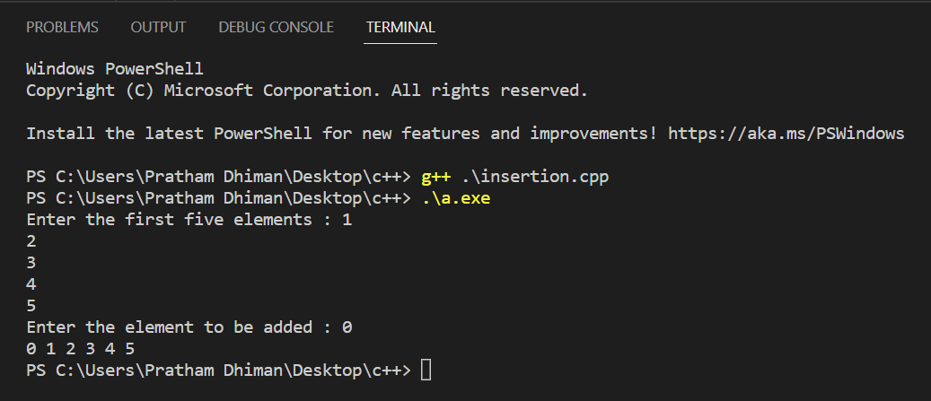

**ii) At the end:**

**Code:**

#include <iostream>

using namespace std;

int main()

{

int arr[100] = {0};

cout<<"Enter the first five elements : ";

for(int i = 0; i < 5; i++){

cin>>arr[i];

}

int element;

cout<<"Enter the element to be added : ";

cin>>element;

arr[5] = element;

for(int i = 0; i <= 5; i++){

cout<<arr[i]<<" ";

}

return 0;

}

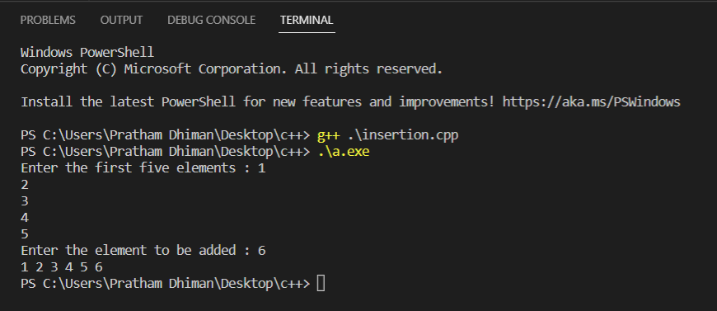**Output:**

**iii) At a given position in the array:**

**Code:**

#include <iostream>

using namespace std;

int main()

{

int arr[100] = {0};

cout<<"Enter the first five elements : ";

for(int i = 0; i < 5; i++){

cin>>arr[i];

}

int element;

cout<<"Enter the element to be added : ";

cin>>element;

int pos;

cout<<"Enter the position(index) : ";

cin>>pos;

if(pos >= 5){

arr[pos] = element;

for(int i = 0; i <= pos; i++){

cout<<arr[i]<<" ";

}

}

else{

for(int i = 4; i >= pos; i--){

arr[i+1] = arr[i];

}

arr[pos] = element;

for(int i = 0; i <= 5; i++){

cout<<arr[i]<<" ";

}

}

return 0;

}

**Output :**

